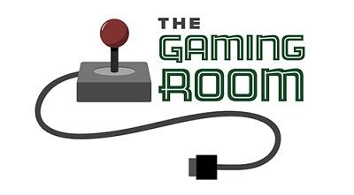

Draw It or Lose It

CS 230 Project Software Design Template
Version 1.0

Table of Contents

1.CS 230 Project Software Design Template 1
Table of Contents 2
Document Revision History 2
Executive Summary 3
Requirements 3
Design Constraints 3
System Architecture View 3
Domain Model 3
Evaluation 4
Recommendations 5
2.Operating Platform: <Recommend an appropriate operating platform that will allow The Gaming Room to expand Draw It or Lose It to other computing environments.> 5
3.Operating Systems Architectures: <Describe the details of the chosen operating platform architectures.> 5
4.Storage Management: <Identify an appropriate storage management system to be used with the recommended operating platform.> 5
5.Memory Management: <Explain how the recommended operating platform uses memory management techniques for the Draw It or Lose It software.> 5
6.Distributed Systems and Networks: <Knowing that the client would like Draw It or Lose It to communicate between various platforms, explain how this may be accomplished with distributed software and the network that connects the devices. Consider the dependencies between the components within the distributed systems and networks (connectivity, outages, and so on).> 5
7.Security: <Security is a must-have for the client. Explain how to protect user information on and between various platforms. Consider the user protection and security capabilities of the recommended operating platform.> 5

Document Revision History

Version | Date | Author | Comments
1.0 | 07/19/24 | Jacob Lee | Initial draft of software design document, including executive summary, requirements, design constraints, domain model, evaluation, and recommendations.
1.1 | 08/03/24 | Jacob Lee | Additions to Evaluation table, including additional server-based advantages and disadvantages, client-considerations, and development requirements for each platform
1.2 | 08/17/24 | Jacob Lee | Additions and revisions to the Recommendations section, expanding on possibilities, tools, and reasoning for each.

Instructions
Fill in all bracketed information on page one (the cover page), in the Document Revision History table, and below each header. Under each header, remove the bracketed prompt and write your own paragraph response covering the indicated information.

Executive Summary

The Gaming Room aims to expand their game, Draw It or Lose It, from an Android-only app to a web-based application accessible across multiple platforms. The proposed solution leverages object-oriented principles and design patterns to employ scalability, unique identifiers, and single-instance memory management to provide a robust and efficient gaming experience.

Requirements

The game must support multiple teams and players with unique names for each game, team, and player. A single instance of the game should exist in memory at any given time, requiring the use of unique identifiers and design patterns such as Singleton and Iterator to manage game state and name uniqueness efficiently.

Design Constraints

- The application must be compatible across various operating systems and devices.
- Implement mechanisms to ensure unique identifiers for games, teams, and players to maintain data integrity.
- Use the Singleton pattern to ensure only one instance of the GameService class exists in memory.
- Implement the Iterator pattern to ensure unique game and team names.

System Architecture View

Please note: There is nothing required here for these projects, but this section serves as a reminder that describing the system and subsystem architecture present in the application, including physical components or tiers, may be required for other projects. A logical topology of the communication and storage aspects is also necessary to understand the overall architecture and should be provided.

Domain Model

The UML class diagram for the game application consists of several key classes: Entity, Game, Team, Player, GameService, ProgramDriver, and SingletonTester.
The Entity base class includes the common attributes 'id' and 'name', with corresponding methods to get the ID and name. Using this, code can be reused and remain consistent across different entities in the application.
The Game, Team, and Player classes all inherit from the 'Entity' class, utilizing the common attributes and behaviors defined in that class. The 'Game' class manages a list of 'Team' objects, which manage a list of 'Player' objects; this illustrates the composition relationship.
The GameService class manages the game logic and uses static variables to assign unique identifiers for games, teams, and players. It implements the Singleton pattern to ensure only one instance exists and uses the Iterator pattern in methods like 'addGame' and 'getGame' to maintain name uniqueness.
The ProgramDriver and SingletonTester classes are used to run and test the application, ensuring that the Singleton pattern is correctly implemented and the application functions as expected.

The object-oriented principles demonstrated are:
Inheritance: In how 'Game', 'Team', and 'Player' classes inherit code from 'Entity' and promote reuse of code.
Encapsulation: Attributes are private with public methods to access and modify them to ensure data integrity.
Polymorphism: Objects of different classes (Game, Team, Player) are treated as objects of their common superclass (Entity), enabling method overriding and polymorphic collections.

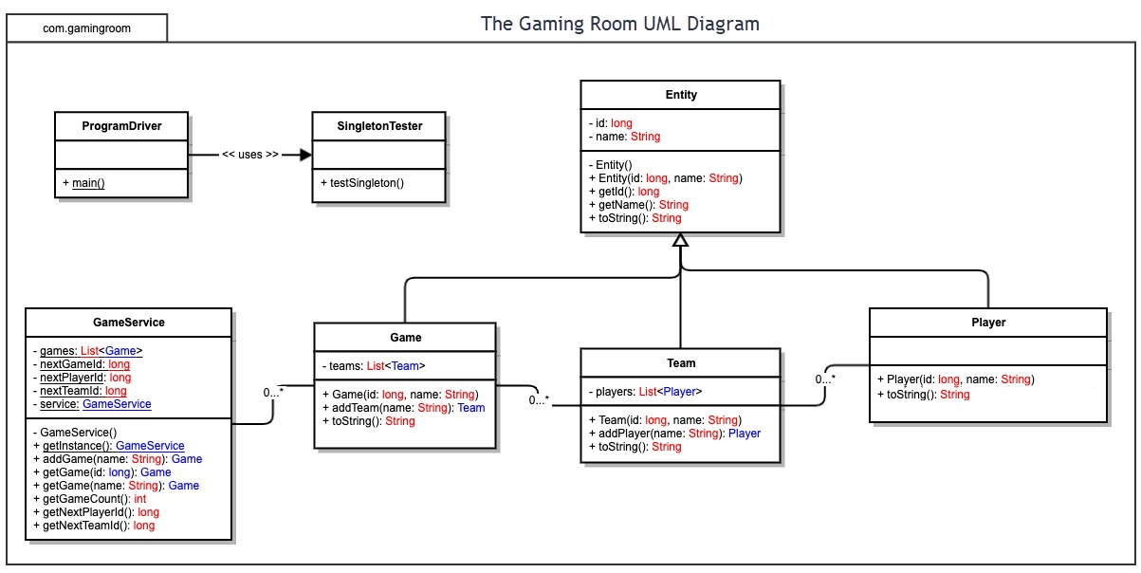

Evaluation

Development Requirements | Mac | Linux | Windows | Mobile Devices
Server Side  Characteristics | Stable;  Secure, Unix-based;  However, less common for servers | Robust;  Secure; Customizable; Widely-used | Familiar; integrates with Microsoft products; widely used in enterprises | Lightweight; optimized;  platform-specific;  Often relies on cloud services
Advantages | High-quality hardware integration, good security features, strong development tools | Excellent performance and scalability;  Extensive community support due to open-source nature | Broad enterprise usage;  Good support for enterprise applications; good performance | Ideal for app-based environments; extensive tools and libraries for development
Weaknesses | Higher costs, smaller user base for server use, less community support | Can be complex to set up and manage for newcomers to Unix-based systems | Higher licensing costs, more security vulnerabilities | Platform-specific, varying screen sizes and performance capabilities
Server-based deployment | Yes, though not as common for large-scale web applications | Yes, e.x. Apache | Yes, e.x. Windows Server | Usually cloud-based services
Licensing costs | Higher costs due to expensiveness of Mac hardware and server software licenses | Generally low to none due to open-source nature of distributions | Higher costs due to proprietary software and licensing fees | Varies depending on cloud service providers
Client Side  Considerations | Smaller user base;  macOS-specific tools;  High quality hardware integration | Diverse environments;  requires expertise;  High customization potential | Largest user base;  cost-effective;  extensive resources;  Broad compatibility | Platform-specific;  varying screen sizes; Requires optimized development for performance
Costs | Higher due to hardware and potential software license costs | Generally low due to open-source nature of development tools and testing environments | Moderate due to potential costs for Windows licenses and proprietary testing tools | Varies depending on development tools and platform-specific distribution fees (e.x. Apple Developer Program)
Time | Moderate, especially if considering Retina display compatibility | Moderate due to thorough testing required across Linux distributions | Moderate to high due to need for extensive cross-browser and cross-device testing | High due to need for extensive testing across multiple different device brands and screen sizes
Expertise | Familiarity with macOS development tools and high-resolution interface design | Knowledge of responsive web design and familiarity with Linux-based development and testing tools | Experience with Windows development environments and comprehensive testing practices | Strong knowledge of mobile development frameworks and responsive web design principles
Development Tools and Languages | Xcode;  Swift;  Objective-C;  cross-platform tools | Java; Python; PHP; Eclipse;  NetBeans;  VS Code;  open-source tools | C#; Visual Studio;  .NET;  cross-platform tools; | Java; Xcode (iOS);  Android Studio;  Flutter;  React Native
Impact on Development Team | Requires Mac hardware and familiarity with macOS development tools | Open-source tools, extensive community support, potential need for Linux expertise | Familiarity with Windows development environments | May require specialized knowledge for each platform, separate development team efforts between OSs
Licensing Costs | Higher | Low to none | Higher | Varies

Recommendations

- Operating Platform: Linux is recommended as the server platform for expanding “Draw It or Lose It” due to Linux's robustness, security, flexibility, and customization. This platform offers extensive community support and cost-effectiveness, making it ideal for scalable and reliable server environments. Additionally, its open-source nature allows for easy adaptation to various hardware configurations, enhancing the ability for the game to be deployed across different platforms with minimal adjustments.

- Operating Systems Architectures: Linux provides efficient process management, security features, and broad hardware support through diverse distributions. Its modularity allows for the inclusion of only necessary components, optimizing performance and security. Linux's architecture also supports multiprocessing, enabling the system to handle multiple operations simultaneously, which is vital for maintaining a seamless gaming experience across platforms. Compared to Windows and macOS, Linux offers superior flexibility and scalability, making it suitable for a distributed gaming environment.

- Storage Management: MySQL or PostgreSQL work well for robust, scalable, efficient data management, which enhances reliability of game data handling. MySQL is easy to install and configure, as well as offering strong security features such as user authentication, access control, and encryption. PostgreSQL supports complex data types and advanced queries. Both are great for scalability. MySQL may be the better option for Draw It or Lose It; it is suitable for simpler applications requiring high performance and ease of use, like a casual-friendly game such as this one.

- Memory Management: Linux employs advanced memory management techniques such as paging, segmentation, and the use of tools like memcached to optimize performance. Paging allows for efficient memory allocation by dividing memory into fixed-sized pages; segmentation provides flexibility by allowing variable-sized segments. Memcached is particularly useful for caching frequently-accessed data, reducing latency and improving the gaming experience for players. With these techniques, the game should operate smoothly even under heavy load and maintain low latency and high efficiency which are important for real-time gaming.

- Distributed Systems and Networks: Middleware is recommended for enabling seamless communication across platforms. Specific middleware solutions such as Apache Kafka for data streaming and Redis for in-memory data storage can handle data consistency, partial failures, and ensure smooth operation even under high loads. Middleware acts as an intermediary, allowing different software components and applications to interact seamlessly, even if they were not originally designed to connect. This setup supports scalability, manages connectivity issues, and facilitates efficient data exchange and real-time communication across various platforms.

- Security: Linux has many built-in security tools and features. Among others:
SSL (Secure Socket Layers)/TLS (Transport Layer Security): These encrypt data in transit between two users, inhibiting interception by malicious actors.
Secure authentication mechanisms: Multi-Factor Authentication (MFA) and Pluggable Authentication Modules (PAM) will require a user to verify their identity with multiple verification factors or complex passwords respectively to hinder brute-force attacks.
Firewalls: 'iptables' and 'firewalld' are Linux tools that create rules to control the flow of incoming and outgoing traffic, blocking unauthorized access while allowing legitimate communication.
IDS (Intrusion Detection Systems)/IPS (Intrusion Prevention Systems): Tools like Tripwire, AIDE, and Snort can monitor network traffic, detect suspicious activities, and generate alerts that enable administrators to respond promptly to potential threats.

